Burundi

## Respect for rule of law (ROL) data

The data set shows the data on the respect of the rule of law for the country.

## # A tibble: 19 x 5  
## country iso3c date ruleOfLaw ruleOfLawCategory4   
## <chr> <chr> <dbl> <dbl> <chr>   
## 1 Burundi BDI 1996 -1.42 ROL highly disrespected   
## 2 Burundi BDI 1998 -1.23 ROL highly disrespected   
## 3 Burundi BDI 2000 -1.35 ROL highly disrespected   
## 4 Burundi BDI 2002 -1.25 ROL highly disrespected   
## 5 Burundi BDI 2003 -1.40 ROL highly disrespected   
## 6 Burundi BDI 2004 -1.54 ROL highly disrespected   
## 7 Burundi BDI 2005 -1.15 ROL highly disrespected   
## 8 Burundi BDI 2006 -0.970 ROL moderately disrespected  
## 9 Burundi BDI 2007 -1.06 ROL highly disrespected   
## 10 Burundi BDI 2008 -1.02 ROL highly disrespected   
## 11 Burundi BDI 2009 -1.15 ROL highly disrespected   
## 12 Burundi BDI 2010 -1.20 ROL highly disrespected   
## 13 Burundi BDI 2011 -1.14 ROL highly disrespected   
## 14 Burundi BDI 2012 -1.08 ROL highly disrespected   
## 15 Burundi BDI 2013 -1.07 ROL highly disrespected   
## 16 Burundi BDI 2014 -0.966 ROL moderately disrespected  
## 17 Burundi BDI 2015 -1.17 ROL highly disrespected   
## 18 Burundi BDI 2016 -1.46 ROL highly disrespected   
## 19 Burundi BDI 2017 -1.40 ROL highly disrespected

## Respect for rule of law (ROL) trend

The plot shows the trend of the respect for the rule of law for the country.

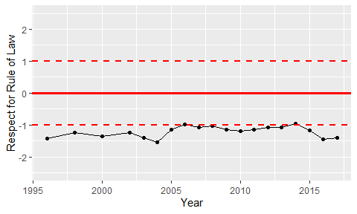

Trend of the Respect for the Rule of Law